JOUR 4251
Psychology of Advertising 2.1 Functions of advertising / introduction to psychology (continued)
TA sections
Questions?
Please contact your TA first following the alphabetical rule above. Their contact information is on Canvas
Email = short questions or making appointments. Mention “JOUR 4251” in subject of email.
Office hours = explanations
New students
● Read syllabus
● Check slides
● Catch up with readings ● Ask for notes
● Set up notifications for the announcements in Canvas
Recap Thursday
● Hard-sell versus soft-sell approach ● Alpha vs. omega strategies ● Psychology and experiments ● Message characteristics
○ Message sidedness
■ One sided
■ Two sided
○ Source
■ Direct
■ Indirect
Are ads effective?
Modelling approach
● Sales response models Behavioral paradigm
● Hierarchy-of-effects models ● Cognitive response models ● Dual process models
Sales response model
Concave: the more you spend, the less your return
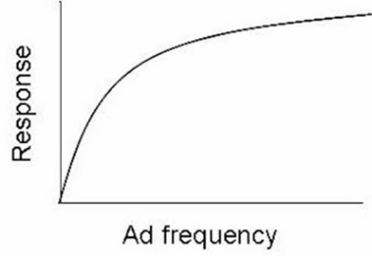
Sales response model
S-shape: Takes a certain amount to work, then works well, then drops off
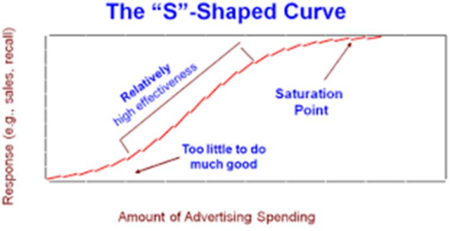
Sales response models
Criticism:
● Other factors that drive sales ● Interaction effects
● External factors
○ Competition
○ Economic factors
○ Sociocultural factors
Hierarchy of effects
No DIRECT link between message and response.
There are steps in between. Learning stages.
3 Stages:
1. Cognitive (think)
Consumers engage in directing attention to the advertisement and thinking about it 2. Affective (feel)
Thinking gives way to emotional responses and formation of attitudes and preferences 3. Conative (do)
Behaviors that may arise - buying product
Do you think you go through those stages - just from your
own life?

AIDA sequences
Hierarchy effect model from 1898
1. Attention (cognitive)
2. Interest and Desire (affective) 3. Action (behavioral)
Other hierarchy effect models
1. AIDCA (Attention, interest, desire, conviction, action) 2. AIETA (Awareness, interest, evaluation, trial adoption) 3. Awareness, knowledge, liking, preference, conviction, purchase
What is the problem with this?
● Sequence: think-feel-do
● High involved consumers
Foote, Cone & Belding Grid
_{High involvemen}t _{Low involvemen}t
Thinking Feeling
Foote, Cone & Belding Grid
_{High involvemen}t _{Low involvemen}t
Thinking Feeling
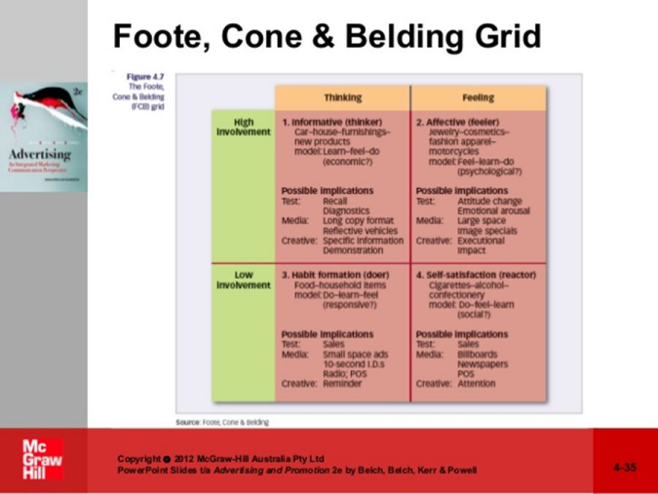
Hierarchy-of-effects models
No strong evidence that we proceed through hierarchy of effects! Criticism:
● Sequence: think-feel-do
● High involvement consumer
● Passive consumer
Consumer behavior is too complex, focus on processes that drive consumer judgement and decision-making
Cognitive response approach
Doesn’t it matter what you THINK?
Active consumer
Positive, neutral or negative thoughts
Can lead to persuasion, resistance, or unchanged positionCriticism?
Are you thoughtful and focused
on the message always?
Dual process theories
More complex responses are considered.
One side: effortful, slow, analytical
Other side, automatic, fast, implicit, impulsive Depends on MOTIVATION to process the message
Ego-depletion
● Assumes we have a limited pool of mental resources to draw upon ● Assumes that when energy is low (depleted), we will have a ‘drained’ feeling
● When this occurs, self-control and ability to control behavior in different ways is impaired
Relation to advertising?
Are ads effective?
Important to note: you are not always consciously aware
What’s next?
Due by the start of Thursday’s class (Jan 30, 2:30 pm):
● Submit assignment 1
○ Install LockDown browser. Do not wait until the last minute!
● Submit reading response on Chapter 1
○ Upload Word/PDF document on Canvas
We do not accept late submissions (unless you use a token). See syllabus for more information.

